Flow fields

# Types of fields (3 types)

## Cost field

* Hold cost-to
* Used as input for building the flow field
* 8-bit field
* Possible value 0-255
  + 255 is wall
  + 1-254 traversable
* Minimum cost is 1

## Integration field

* 24-bit field
* First 16 bits -> Total integrated cost
* Second 8 bits -> used for integration flags
* Optionally spend more memory bot better flow results (eg: 32-bit float integrated cost)

## Flow field

* 8-bit fields
* First 4 bits -> index into direction lookup table
* Second 4 bits -> flags

# Implementation

## Step 1: Generate Cost-field

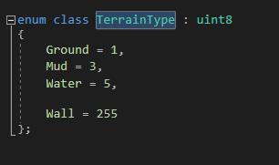It’s not necessary to generate an extra cost field, since all the nodes contain the cost to travel to them.

Currently there are 4 types of terrain:

* Ground (cost =1)
* Mud (cost = 3)
* Water (cost = 5)
* Wall (cost = 255)

The cost/terrain is stored in a uint8, since we don’t need more numbers for the scale of this demo. If more would be needed, it would be as easy as using a larger size integer or even a float.

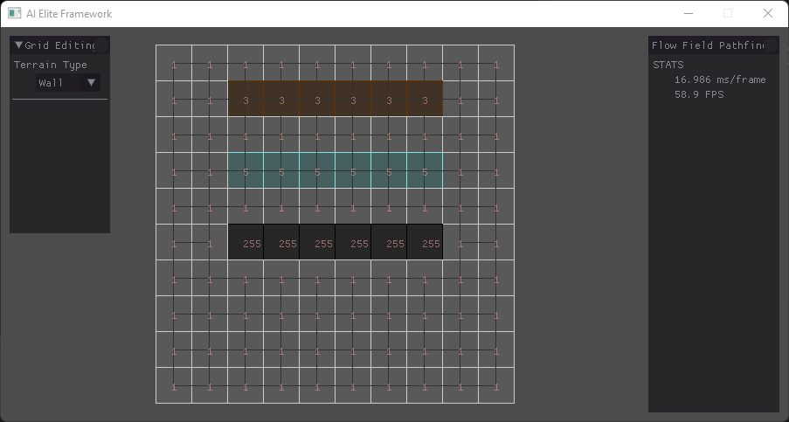This is how the ‘Cost-field” looks with debug rendering.